Project Design Phase-II
Data Flow Diagram & User Stories

Date | 20 Feb 2026
Team ID | LTVIP2026TMIDS24859
Project Name | Calculate family Expenses using Service Now
Mentor Name | Dr Shaik Salma Begum
Maximum Marks | 4 Marks

Data Flow Diagrams:
A Data Flow Diagram (DFD) is a traditional visual representation of the information flows within a system. A neat and clear DFD can depict the right amount of the system requirement graphically. It shows how data enters and leaves the system, what changes the information, and where data is stored.
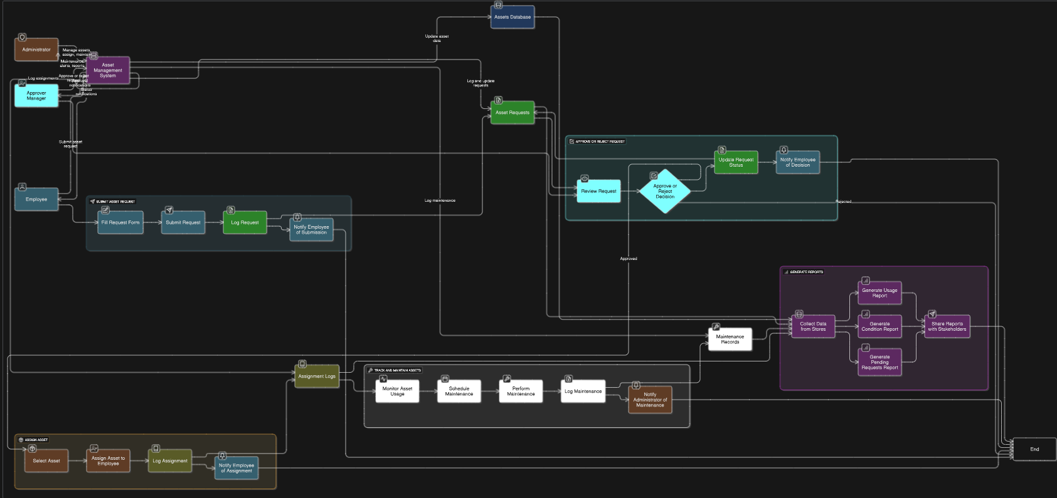
User Stories
User Type | Functional Requirement (Epic) | User Story Number | User Story / Task | Acceptance Criteria | Priority | Release
Developer | PDI Setup | USN-1 | As a developer, I can set up a Personal Developer Instance | Instance is created, accessible, and ready for development | High | Sprint-1
Developer | Update Set Creation | USN-2 | As a developer, I can create and activate an Update Set | Update set is active and captures all configuration changes | High | Sprint-1
Admin | Table Creation | USN-3 | As an admin, I can create Family Expenses table with auto-numbering | Table created and records have auto-generated unique numbers | High | Sprint-1
Admin | Table Creation | USN-4 | As an admin, I can create Daily Expenses table with required fields | Table created with fields: Date, Expense, Family Member, Comments | High | Sprint-1
Admin | Relationship Configuration | USN-5 | As an admin, I can link Daily Expenses to Family Expenses | Related list displays Daily Expenses in Family Expenses form | High | Sprint-2
Admin | Business Rule Automation | USN-6 | As an admin, I can configure business rule to auto-calculate total expenses | Total amount updates automatically when Daily Expense is added | High | Sprint-2
User | Expense Entry | USN-7 | As a user, I can add daily expense details | Expense record is saved and visible in Daily Expenses table | High | Sprint-2
User | Expense Summary | USN-8 | As a user, I can view summarized family expenses | Family Expenses table shows total daily expenses correctly | Medium | Sprint-3
Admin | Form Configuration | USN-9 | As an admin, I can configure forms and fields properties | Fields are read-only or mandatory as per requirements | Medium | Sprint-3
Admin | Reporting | USN-10 | As an admin, I can generate expense reports | Reports display total expenses and expense trends | Medium | Sprint-4

